

Foundations of Programming

Assignment No.: 18
PROBLEM STATEMENT: Write a C program that accepts a string from the user and performs the following string operations: i) Calculate length of string ii) String reversal iii) Equality check of two strings iv) Check palindrome v) Check substring.

OBJECTIVE:

- To understand basic string operations in C.
- To learn how to manipulate strings using loops and functions.
- To perform comparison, reversal, and substring checking.
- To check whether a string is a palindrome.

THEORY:
In C programming, a string is a sequence of characters terminated by a null character ('\0'). Strings are commonly stored in character arrays. Various operations can be performed on strings such as calculating their length, reversing the characters, comparing two strings, checking whether a string is a palindrome, and finding a substring within another string. These operations can be implemented using loops and conditional statements or by using standard library functions from the string.h header file.

Algorithm:
- Start
- Declare character arrays: str, str2, rev, sub.
- Read a string str from the user.
- Find Length of String
  - Initialize i = 0.
  - Repeat until str[i] == '\0':
    - Increment i.
  - Length = i.
  - Display the length.
- Reverse the String
  - Find length of str.
  - For i = 0 to length - 1:
    - Set rev[i] = str[length - i - 1].
  - Set rev[i] = '\0'.
  - Display reversed string.
- Equality Check of Two Strings
  - Read another string str2.
  - Initialize i = 0.
  - Compare characters of str[i] and str2[i] one by one.
  - If any character differs, strings are not equal.
  - If both strings end at the same time, strings are equal.
  - Display the result.
- Palindrome Check
  - Find length of str.
  - For i = 0 to length / 2:
    - Compare str[i] with str[length - i - 1].
  - If any pair is different, it is not a palindrome.
  - If all pairs match, it is a palindrome.
  - Display the result.
- Substring Check
  - Read a substring sub.
  - Find lengths of str and sub.
  - For i = 0 to length(str) - length(sub):
    - For j = 0 to length(sub) - 1:
      - Compare str[i + j] with sub[j].
    - If all characters match, substring is found.
  - If no match found after loop, substring not found.
  - Display the result.
- Stop

FLOWCHART:
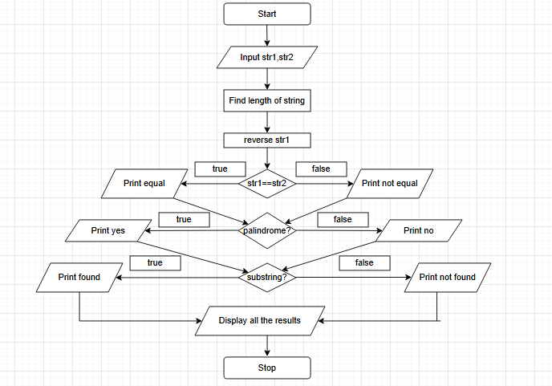

CODE:
#include <stdio.h>
#include <string.h>

// Remove trailing newline added by fgets
void removeNewline(char str[]) {
int len = strlen(str);
if (len > 0 && str[len - 1] == '\n') {
str[len - 1] = '\0';
}
}

// Function to calculate string length
int strLength(char str[]) {
int i = 0;
while (str[i] != '\0')
i++;
return i;
}

// Function to reverse string
void reverseString(char str[], char rev[]) {
int len = strLength(str);
int i;
for (i = 0; i < len; i++) {
rev[i] = str[len - i - 1];
}
rev[i] = '\0';
}

// Function to check equality of two strings
int isEqual(char str1[], char str2[]) {
int i = 0;
while (str1[i] != '\0' && str2[i] != '\0') {
if (str1[i] != str2[i])
return 0;
i++;
}
return (str1[i] == '\0' && str2[i] == '\0');
}

// Function to check palindrome
int isPalindrome(char str[]) {
int len = strLength(str);
for (int i = 0; i < len / 2; i++) {
if (str[i] != str[len - i - 1])
return 0;
}
return 1;
}

// Function to check substring
int isSubstring(char str[], char sub[]) {
int len1 = strLength(str);
int len2 = strLength(sub);

for (int i = 0; i <= len1 - len2; i++) {
int j;
for (j = 0; j < len2; j++) {
if (str[i + j] != sub[j])
break;
}
if (j == len2)
return 1;
}
return 0;
}

int main() {
char str[100], str2[100], rev[100], sub[100];

// Input string
printf("Enter a string: ");
fgets(str, sizeof(str), stdin);
removeNewline(str);

// Length
printf("Length of string: %d\n", strLength(str));

// Reverse
reverseString(str, rev);
printf("Reversed string: %s\n", rev);

// Equality check
printf("Enter another string for comparison: ");
fgets(str2, sizeof(str2), stdin);
removeNewline(str2);

if (isEqual(str, str2))
printf("Strings are equal\n");
else
printf("Strings are not equal\n");

// Palindrome check
if (isPalindrome(str))
printf("String is a palindrome\n");
else
printf("String is not a palindrome\n");

// Substring check
printf("Enter substring to check: ");
fgets(sub, sizeof(sub), stdin);
removeNewline(sub);

if (isSubstring(str, sub))
printf("Substring found\n");
else
printf("Substring not found\n");

return 0;
}
PLATFORM: Linux

INPUT:
Enter a string: madam
Enter another string for equality check: mad

OUTPUT:
Length of string = 5
Reversed string = madam
The string is a Palindrome
Strings are not equal
Substring found in main string

CONCLUSION: Thus, the C program successfully performs different string operations such as length calculation, reversal, equality check, palindrome check, and substring detection.

FAQs:
- What is a string in C programming?
- Which header file is required for string functions?
- What function is used to find the length of a string?
- What is a palindrome string?
- Which function is used to check a substring in C?

